Date -

Experiment – 8
XML, XSLT, SACS, XPATH

PROGRAM 1:

AIM:
To design an XML document that stores information about patients in a hospital. Information about parents must include their name (in three parts), Social Security Number, age, room number, primary insurance company – including member identification number, group number, phone number, and address – seconary insurance company (wit same parts as the primary insurance company has), known medical problems, and known drug allergies. Both attributes and nested tags ust be included. Make up a sample data for atleast four patients.

PROGRAM :

<hospital>

<patient>
<name firstname="A" middlename="B" lastname="C" />
<sex>Male</sex>
<room-number>1</room-number>
<age>40</age>
<social-security-number>1234</social-security-number>
<primary-insurance-company>
<id>11</id>
<group-id>21</group-id>
<phone>1111111111</phone>
<address>Chennai</address>
</primary-insurance-company>
<secondary-insurance-company>
<id>21</id>
<group-id>41</group-id>
<phone>2222222222</phone>
<address>Madurai</address>
</secondary-insurance-company>
</patient>

<patient>
<name firstname="x" middlename="Y" lastname="Z" />
<sex>Male</sex>
<room-number>2</room-number>
<age>20</age>
<social-security-number>1234</social-security-number>
<primary-insurance-company>
<id>12</id>
<group-id>31</group-id>
<phone>1111111111</phone>
<address>Mumbai</address>
</primary-insurance-company>
<secondary-insurance-company>
<id>22</id>
<group-id>51</group-id>
<phone>2222222222</phone>
<address>Delhi</address>
</secondary-insurance-company>
</patient>

</hospital>

OUTPUT:

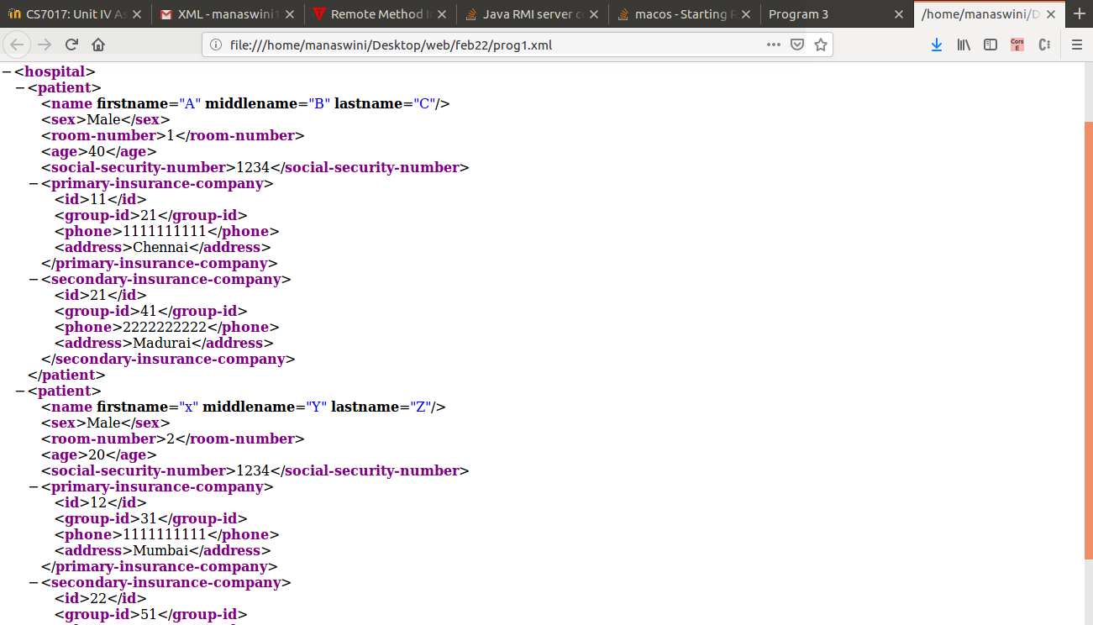

RESULT:
Thus the program is executed and output is obtained.

PROGRAM 2:

AIM :
To write a DTD for the ocument described in Program 1, but with the following restrictions: name, Social Security number, age, room number, and primary insurance company are required. All the other elements are optional, as are middle names.

PROGRAM :

<!ELEMENT hospital (patient)>
<!ELEMENT patient (name,sex,room-number,age,social-security-number,primary-insurance-company,secondary-insurance-company)>
<!ELEMENT name (#PCDATA)>
<!ATTLIST firstname #REQUIRED>
<!ATTLIST middlename >
<!ATTLIST lastname #REQUIRED>
<!ELEMENT age(#PCDATA) #REQUIRED>
<!ELEMENT sex(#PCDATA) #REQUIRED>
<!ELEMENT room-number (#PCDATA) #REQUIRED>
<!ELEMENT social-security-number(#PCDATA) #REQUIRED>
<!ELEMENT primary-insurance-company (id,group-id,phone,address) #REQUIRED>
<!ELEMENT id (#PCDATA)>
<!ELEMENT group-id (#PCDATA)>
<!ELEMENT phone (#PCDATA)>
<!ELEMENT address (#PCDATA)>
<!ELEMENT secondary-insurance-company (id,group-id,phone,address)>

RESULT:
Thus the program is executed and output is obtained.

PROGRAM 3:

AIM :
To create a CSS style sheet for the XML document of program 1 and use it to create a display of thet document.

PROGRAM :

name,sex, room-number, age, social-security-number{
color: blue;
font-family: verdana;
font-size: 200%;
display : block;
}

hospital {
border: 1px solid powderblue;
display : block;
}

sex{
color: white;
background-color : gray;
width: 200%;
}

primary-insurance-company, secondary-insurance-company{
font-size : 25px;
font-weight : bold;
}

OUTPUT:

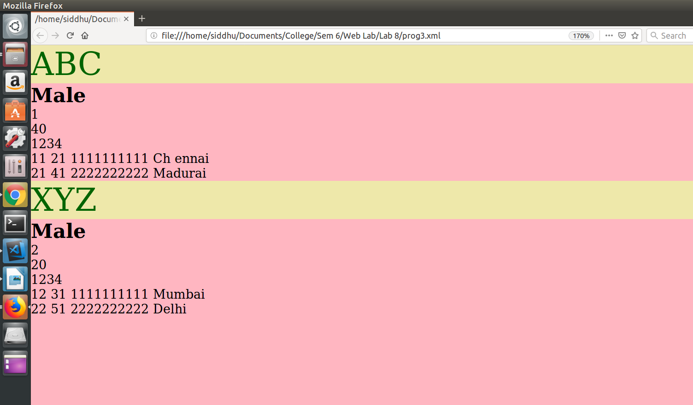
RESULT:
Thus the program is executed and output is obtained.
PROGRAM 4:

AIM:
To create an XSLT sylesheet for one patient element of the XML document of program 1 and use it to create a display of that element.

PROGRAM :

<?xml version="1.0" encoding="UTF-8"?>
<xsl:stylesheet version="1.0" xmlns:xsl="http://www.w3.org/1999/XSL/Transform">
<xsl:template match="/">
<html>
<body bgcolor="blue">
<h2 align="center" style="color:yellow font-family:helvetica">Patient History</h2>
<table border="1" align="center">
<tr bgcolor="green">
<th style="text-align:left font-size:100%">FName</th>
<th style="text-align:left font-size:100%">MName</th>
<th style="text-align:left font-size:100%">LName</th>
<th style="text-align:left font-size:100%">Sex</th>
<th style="text-align:left font-size:100%">Room-number</th>
<th style="text-align:left font-size:100%">Age</th>
<th style="text-align:left font-size:100%">Social Security Number</th>
<th style="text-align:left font-size:100%">SIC:ID</th>
<th style="text-align:left font-size:100%">SIC:GrpID</th>
<th style="text-align:left font-size:100%">SIC:Phone</th>
<th style="text-align:left font-size:100%">SIC:Address</th>
<th style="text-align:left font-size:100%">SIC:ID</th>
<th style="text-align:left font-size:100%">SIC:GrpID</th>
<th style="text-align:left font-size:100%">SIC:Phone</th>
<th style="text-align:left font-size:100%">SIC:Address</th>
</tr>
<xsl:for-each select="hospital/patient[name='XYZ']">
<tr>
<td><xsl:value-of select="name/@firstname"/></td>
<td><xsl:value-of select="name/@middlename"/></td>
<td><xsl:value-of select="name/@lastname"/></td>
<td><xsl:value-of select="sex"/></td>
<td><xsl:value-of select="room-number"/></td>
<td><xsl:value-of select="age"/></td>
<td><xsl:value-of select="social-security-number"/></td>
<td><xsl:value-of select="primary-insurance-company/id"/></td>
<td><xsl:value-of select="primary-insurance-company/group-id"/></td>
<td><xsl:value-of select="primary-insurance-company/phone"/></td>
<td><xsl:value-of select="primary-insurance-company/address"/></td>
<td><xsl:value-of select="secondary-insurance-company/id"/></td>
<td><xsl:value-of select="secondary-insurance-company/group-id"/></td>
<td><xsl:value-of select="secondary-insurance-company/phone"/></td>
<td><xsl:value-of select="secondary-insurance-company/address"/></td>
</tr>
</xsl:for-each>
</table>
</body>
</html>
</xsl:template>
</xsl:stylesheet>

OUTPUT:

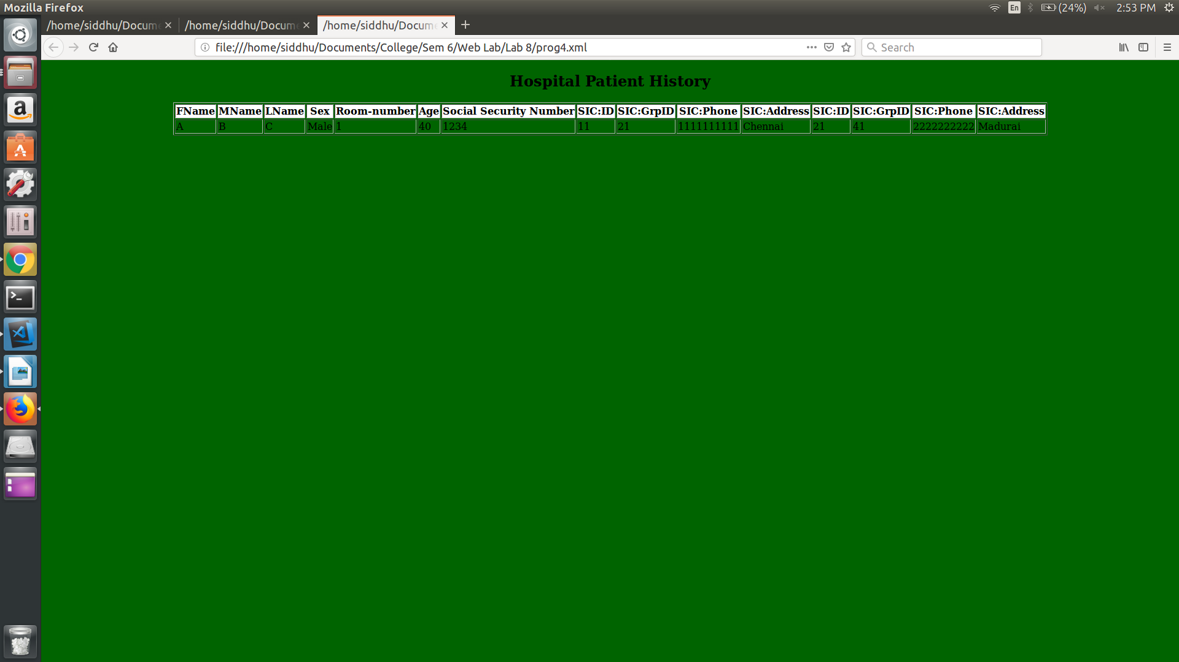

RESULT :
Thus the program is executed and output is obtained.

PROGRAM 5:

AIM :
To modify the XSLT stylesheet of Program 4 so that it formats all the patient elements in the XML document of Program 1 abd use the sylesheet to create a display of the whole document.

PROGRAM :

<?xml version="1.0" encoding="UTF-8"?>
<xsl:stylesheet version="1.0" xmlns:xsl="http://www.w3.org/1999/XSL/Transform">
<xsl:template match="/">
<html>
<body bgcolor="blue">
<h2 align="center" style="color:blue font-family:helvetica">Patient History</h2>
<table border="1" align="center">
<tr bgcolor="green">
<th style="text-align:left font-size:300%">FName</th>
<th style="text-align:left font-size:300%">MName</th>
<th style="text-align:left font-size:300%">LName</th>
<th style="text-align:left font-size:300%">Sex</th>
<th style="text-align:left font-size:300%">Room-number</th>
<th style="text-align:left font-size:300%">Age</th>
<th style="text-align:left font-size:300%">Social Security Number</th>
<th style="text-align:left font-size:300%">SIC:ID</th>
<th style="text-align:left font-size:300%">SIC:GrpID</th>
<th style="text-align:left font-size:300%">SIC:Phone</th>
<th style="text-align:left font-size:300%">SIC:Address</th>
<th style="text-align:left font-size:300%">SIC:ID</th>
<th style="text-align:left font-size:300%">SIC:GrpID</th>
<th style="text-align:left font-size:300%">SIC:Phone</th>
<th style="text-align:left font-size:300%">SIC:Address</th>
</tr>
<xsl:for-each select="hospital/patient">
<tr>
<td><xsl:value-of select="name/@firstname"/></td>
<td><xsl:value-of select="name/@middlename"/></td>
<td><xsl:value-of select="name/@lastname"/></td>
<td><xsl:value-of select="sex"/></td>
<td><xsl:value-of select="room-number"/></td>
<td><xsl:value-of select="age"/></td>
<td><xsl:value-of select="social-security-number"/></td>
<td><xsl:value-of select="primary-insurance- company/id"/></td>
<td><xsl:value-of select="primary-insurance-company/group- id"/></td>
<td><xsl:value-of select="primary-insurance- company/phone"/></td>
<td><xsl:value-of select="primary-insurance- company/address"/></td>
<td><xsl:value-of select="secondary-insurance- company/id"/></td>
<td><xsl:value-of select="secondary-insurance-company/group- id"/></td>
<td><xsl:value-of select="secondary-insurance- company/phone"/></td>
<td><xsl:value-of select="secondary-insurance- company/address"/></td>
</tr>
</xsl:for-each>
</table>
</body>
</html>
</xsl:template>
</xsl:stylesheet>

OUTPUT:

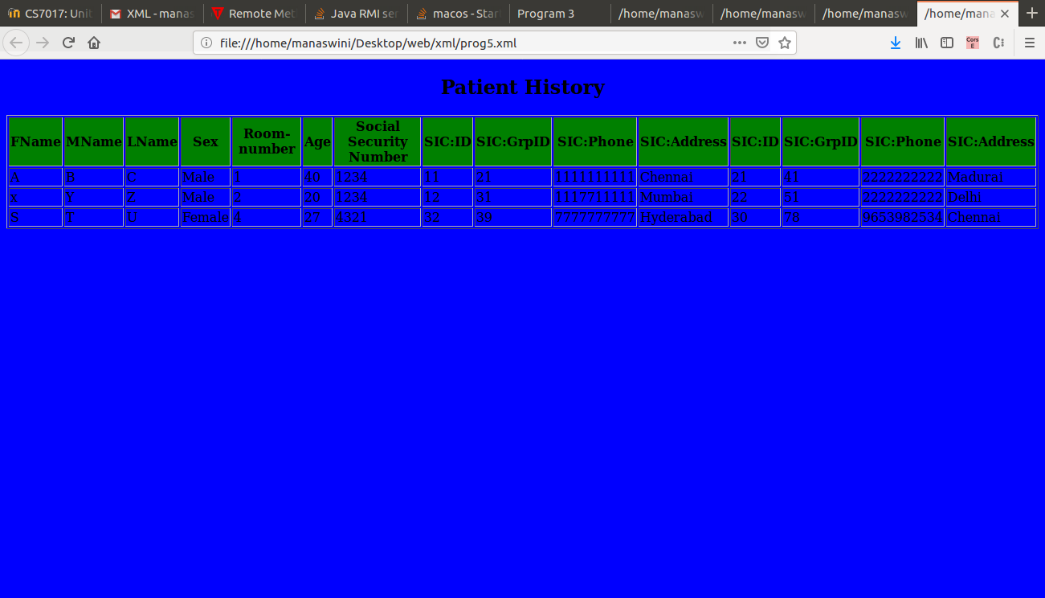

Result:
Thus the program is executed and output is obtained.

